[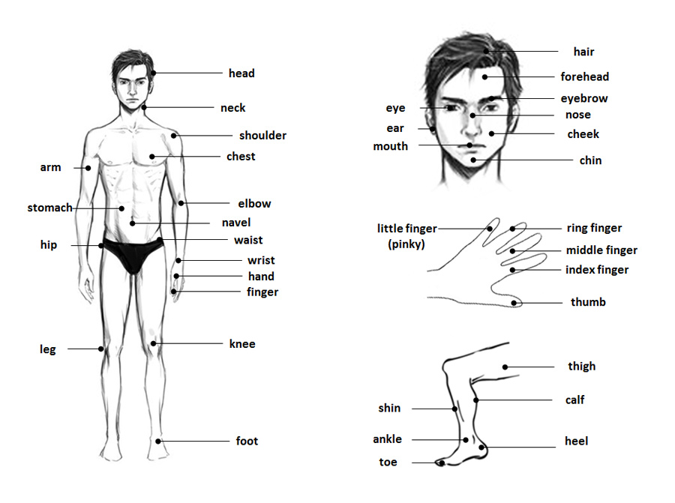](https://www.milujemcestovanie.sk/wp-content/uploads/2013/02/body-parts.jpg)

